*/\* 1 \*/*

*/\* a \*/*

DATA vars;

INPUT X Y Z;

DATALINES;

30 70 25

29 68 27

31 72 17

47 93 20

40 84 10

27 65 38

46 91 36

50 96 29

;

PROC CORR DATA = vars;

RUN;

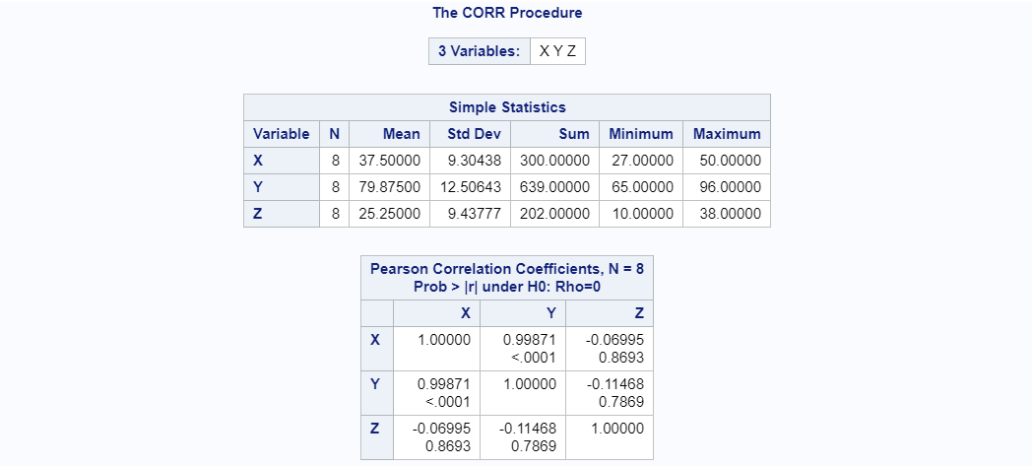

*/\* b \*/*

DATA vars;

INPUT X Y Z;

LX = LOG(X);

DATALINES;

30 70 25

29 68 27

31 72 17

47 93 20

40 84 10

27 65 38

46 91 36

50 96 29

;

PROC CORR DATA = vars;

VAR LX Y;

RUN;

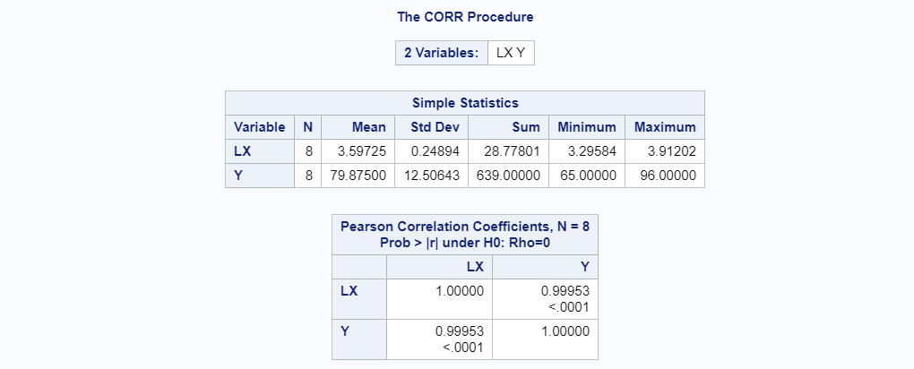

*/\* c \*/*

PROC REG DATA = vars ALPHA = .1;

MODEL Y = LX;

RUN;

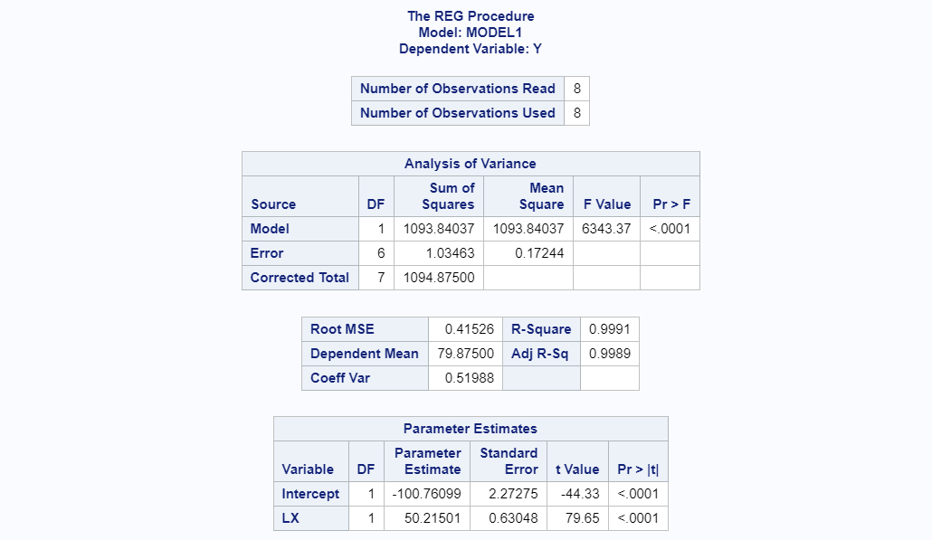

*/\* d \*/*

/\* Slope: 50.21501 / Intercept: -100.76099 / They are sig. diff. from zero. \*/

*/\* e \*/*

PROC REG DATA = vars ALPHA = .1;

MODEL LX=Y;

PLOT PREDICTED.\*LX Y\*LX/ OVERLAY;

RUN;

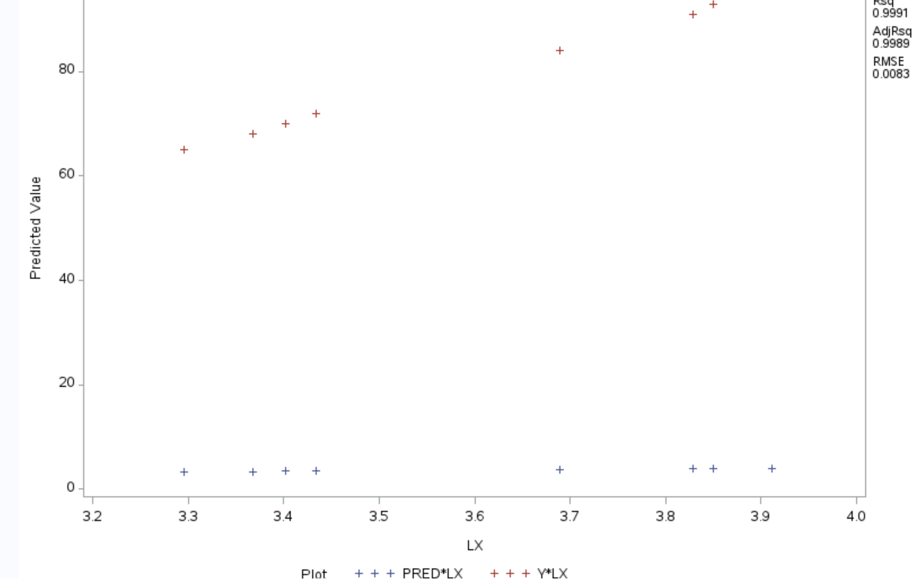

*/\* 2 \*/*

*/\* a \*/*

DATA CHISQ;

INPUT EXAM $ OUTCOME $ COUNT;

DATALINES;

Low Yes 40

Low No 100

High Yes 30

High No 130

;

PROC FREQ DATA = CHISQ;

TABLES EXAM\*OUTCOME / CHISQ ALPHA = 0.01;

WEIGHT COUNT;

RUN;

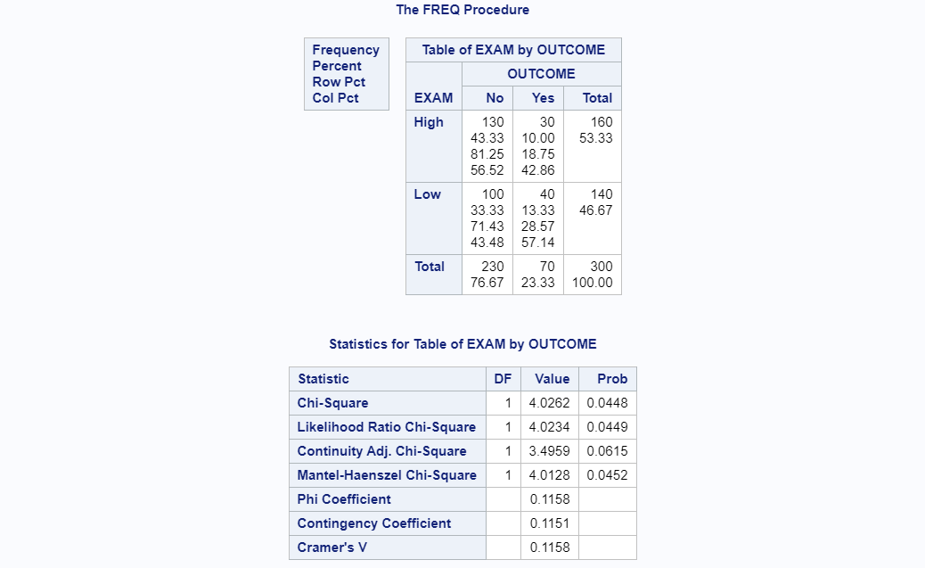

*/\* b \*/*

*/\* 3 \*/*

*/\* a \*/*

DATA MREG;

INPUT X1 X2 X3 X4 Y;

DATALINES;

34 32 44 43 283

2 20 11 9 54

1 36 17 46 77

33 45 18 34 175

22 19 16 30 135

10 50 9 49 72

16 26 2 15 61

36 41 30 23 232

42 2 48 44 322

44 44 15 11 196

;

PROC REG DATA = MREG;

MODEL Y = X1 X2 X3 X4 / noint;

RUN;

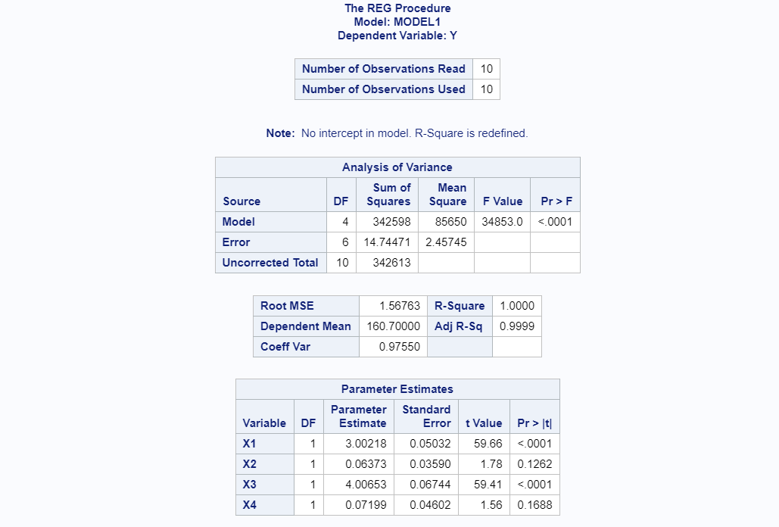

*/\* b \*/*

PROC REG DATA = MREG;

MODEL Y = X1 X2 X3 X4;

RUN;

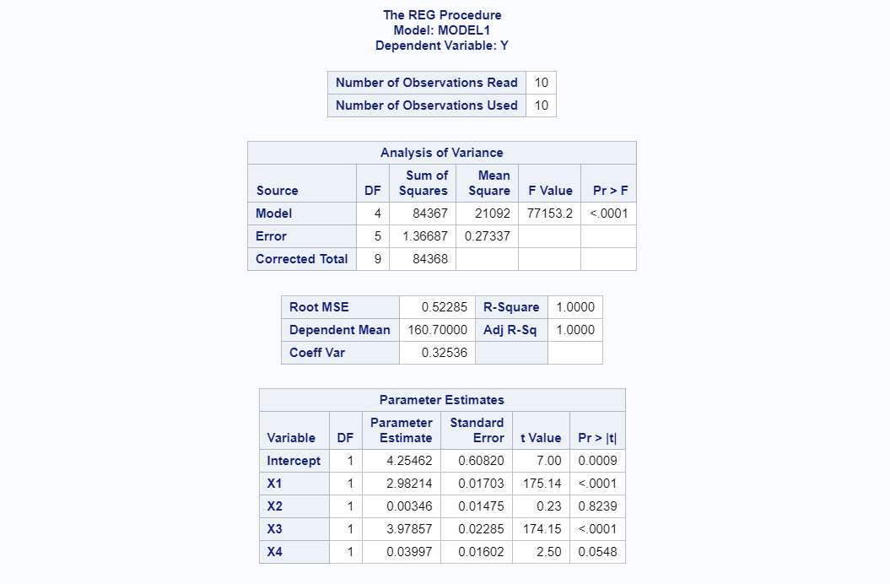

*/\* c \*/*

PROC REG DATA = MREG;

MODEL Y = X1 X2 X3 X4 /selection=RSQUARE;

RUN;

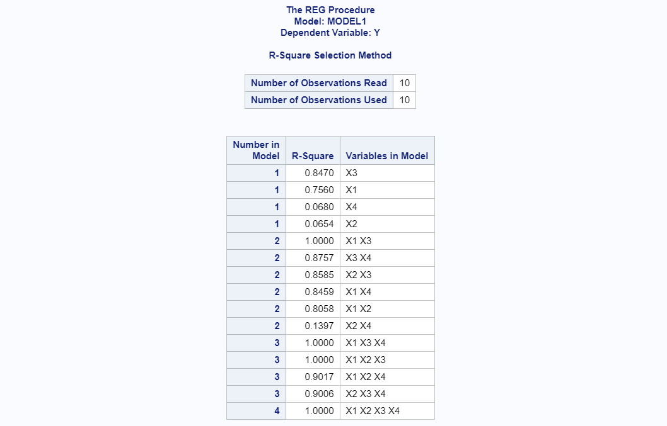

*/\* 4 \*/*

*/\* a \*/*

DATA SCORES;

INPUT EXAM $ SCORE @@;

DATALINES;

A 570 A 530 A 540 A 535 A 585 A 537 A 590

B 555 B 512 B 510 B 520 B 510 B 512 B 570

C 512 C 518 C 555 C 502 C 510 C 520 C 516

D 505 D 508 D 512 D 520 D 543 D 523 D 517

;

PROC ANOVA DATA = SCORES;

CLASS EXAM;

MODEL SCORE = EXAM;

MEANS EXAM / ALPHA = 0.1;

RUN;

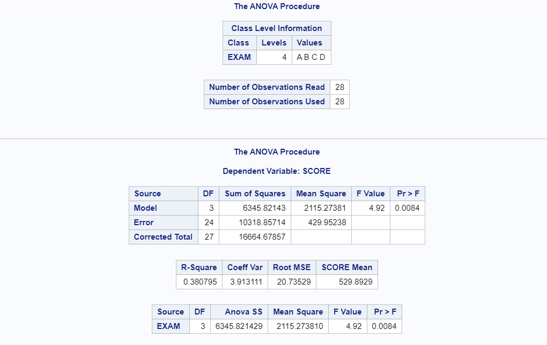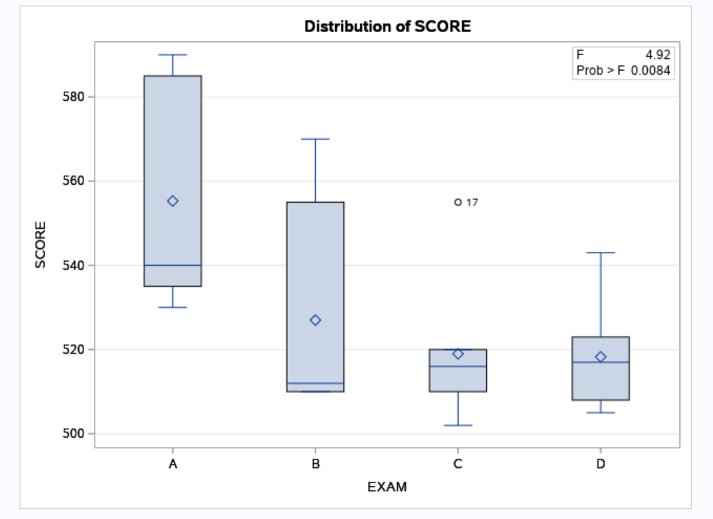

*/\* b \*/*

PROC ANOVA DATA = SCORES;

CLASS EXAM;

MODEL SCORE = EXAM;

MEANS EXAM / ALPHA = 0.1 DUNCAN;

RUN;

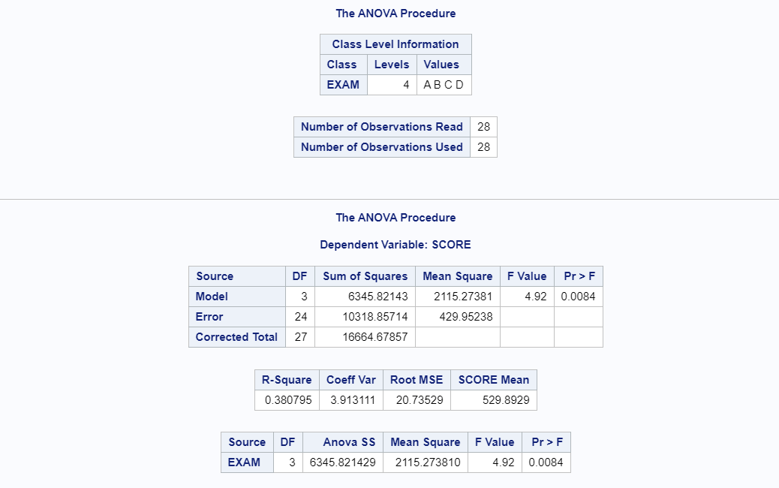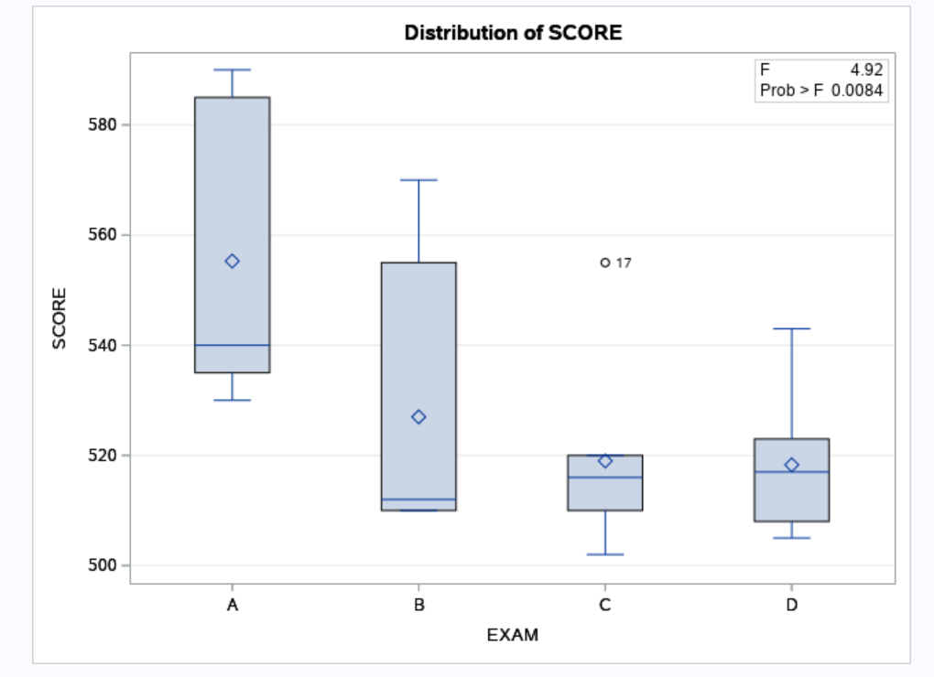

*/\* c \*/*

PROC GLM DATA = SCORES;

CLASS EXAM;

MODEL SCORE = EXAM;

CONTRAST 'A vs B and C' EXAM -2 1 1 0;

RUN;

